Tasking Manager Projects to Field Tasking Manager
Object Sequence Diagram
@startuml
Participant “Tasking Manager” as TM
Participant “Field Tasking Manager” as FTM
TM -> FTM: SomethingProject(TM Project incl Project Id)
FTM -> FTM: Now What?
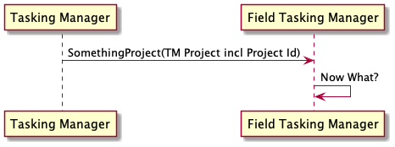
@enduml

